

Consignment Tag Update App

User Document

**ITEM PAGE**

**Main Page**  3

Consignment Tag List 3

PO Assignment Screen 6

# Main Page

## List of consignment tags

When you first open the application, a list of tags will be presented.

You can filer the list by typing under the field and pressing enter. For Example: typing ‘001871TR’ will filter for all consignment tags for Trion.

You can use multiple filters, to get a desired list, for example using a shipto filter and invoice date filter, and using the select all to select all displayed tags and press next to proceed to the apply PO screen.

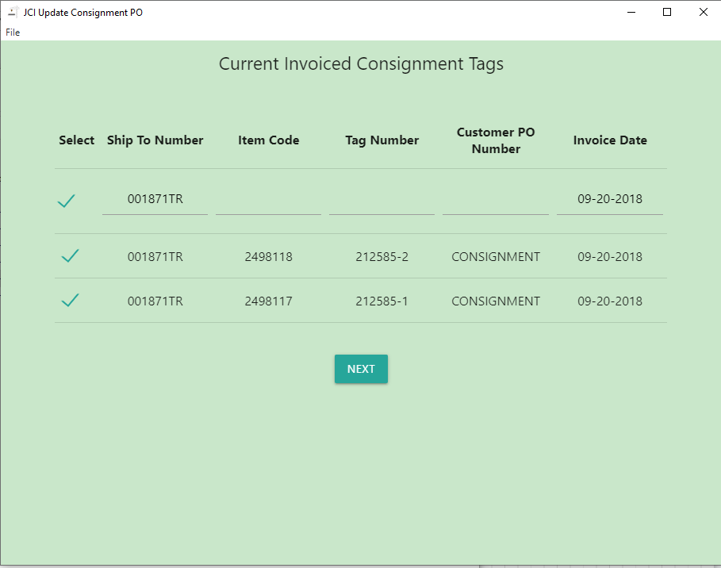

## PO Assignment Screen

When screen is populated, the list of tags selected in the previous screen will be presented. On top of the screen you will enter the ‘PO Number’ and press ‘UPDATE PO’.

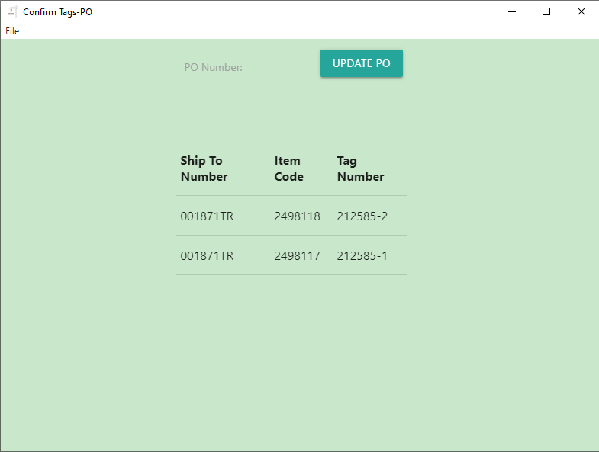

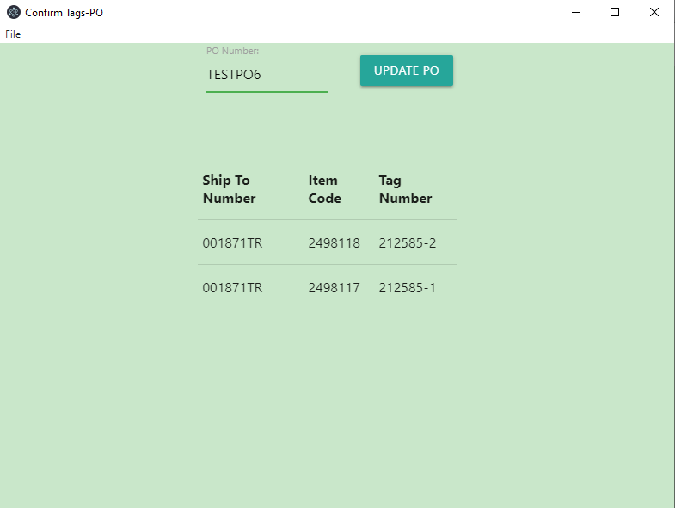

A confirmation screen will appear, confirming the update of the selected tags. Once you press ‘OK’ the update will take place.

Once the update is complete you will receive a Success message. Once the message is closed it will redirect you to the main page.

